# DAD 220 Module Five Activity Template

Complete these steps as you work through the directions for this activity. Refer to the guidelines and rubric for help with how to complete these steps. Rename this template by adding your last name to the file name. Replace the bracketed text in the template with your responses and supporting screenshots as you complete the activity. Size each screenshot and its explanation to fit approximately one-quarter of the page. Review the Template Screenshot Example linked in the guidelines and rubric for this assignment to see how screenshots for your assignment should look. Submit the completed template for grading and feedback.

1. **Analyze the data** provided in FleetMaintenanceRecords **to** **identify themes**.
   1. Review part-replacement frequencies and types. Then create a hypothesis that the fleet management team can use to better handle maintenance.
      1. Create a table called Parts Maintenance. Put this table in the database named after yourself.
      2. Load the data set from the ‘/home/codio/workspace’ path and run queries to find the results. You should use the following line terminators when importing: \r\n.
      3. Answer the following questions and provide supporting screenshots.
         1. Which parts are being replaced most often?

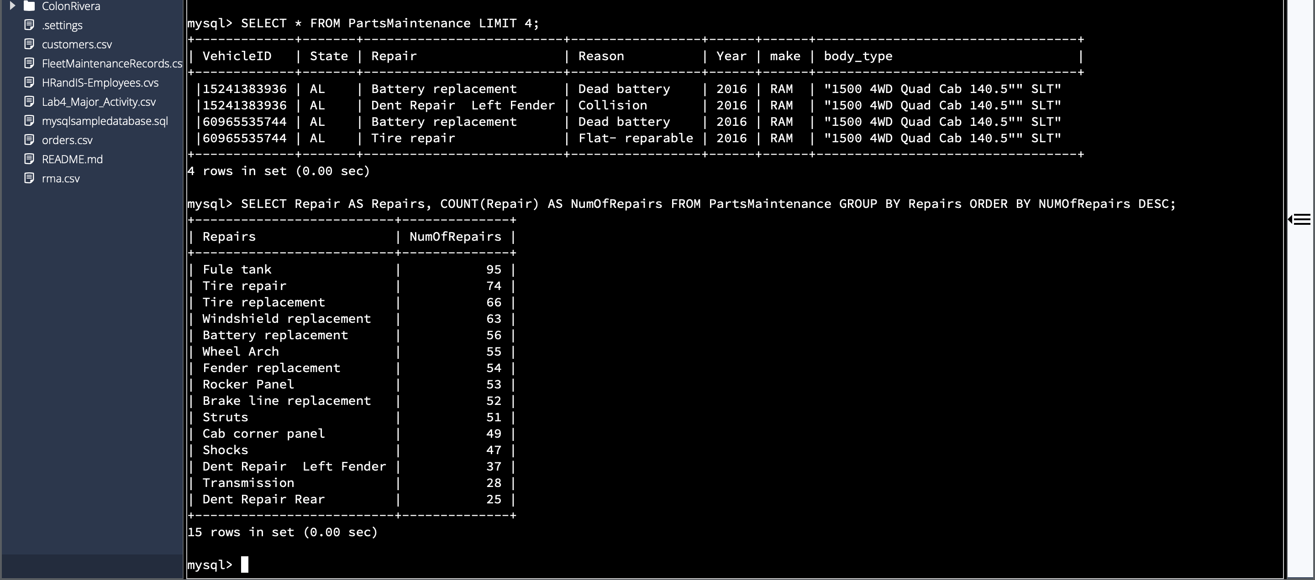

From the table the part that gets replaced the most is the Fuel tank

* + - 1. Which region or regions of the country experience more part failures and replacements than others?
         1. Identify the region or regions with more reasons for the replacement of parts.
         2. Use the Region Definitions sheet to identify states in each region.

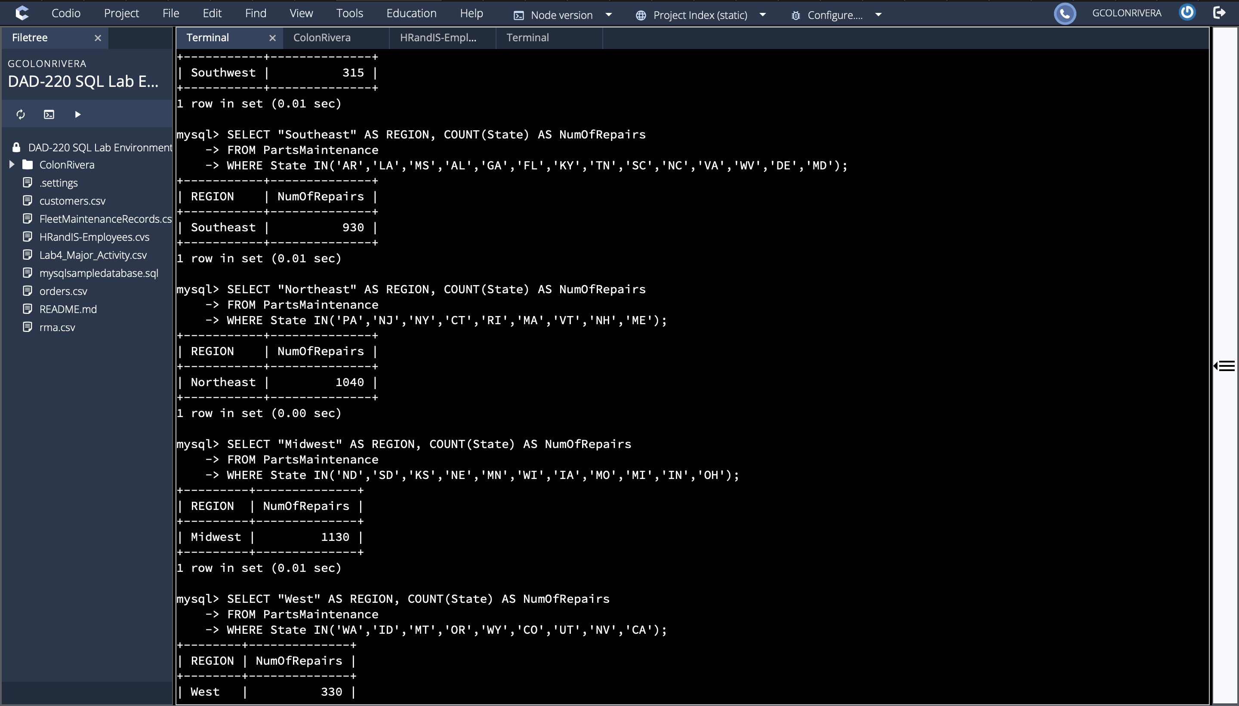

The Midwest region experiences the most part failures

* + - 1. How might the fleet maintenance team use the information to update its maintenance schedule?

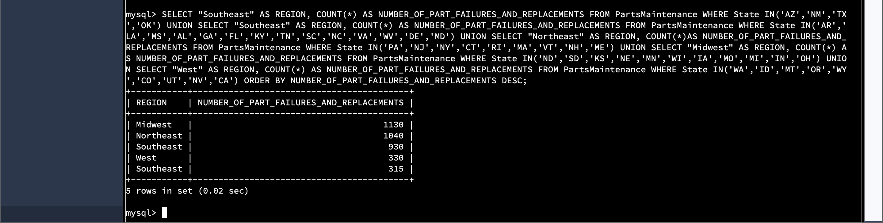

The fleet maintenance team could use the Information to prioritize maintenance schedules based off of the high numbers that need replacements and repairs.

* + - 1. Which parts are being replaced most often due to corrosion or rust?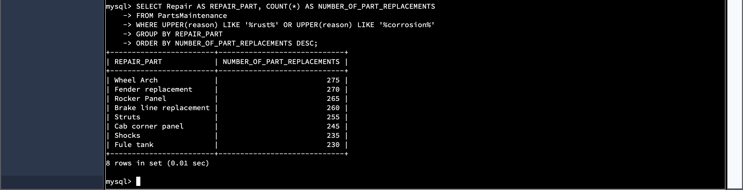
      2. Which parts are being replaced most often because of mechanical failure or an accident like a flat tire or rock through the windshield?

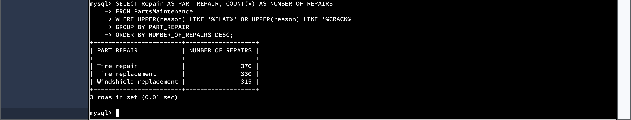

1. **Write a** brief **summary of** your **analysis** thattakes the information from step one and presents it in a way that nontechnical stakeholders can understand. Write your response in paragraph form.

Looking at the data that was provided I can see that the Midwest region

has the most repairs with a total of 1130 reported followed by the north-east in

second with 1040. We can also see that the most common type of repair was the

fuel tank with a total of 475 repairs shown, the country  tire repair with 370. When it comes to rust or corrosion repairs, we can see that the most common was the wheel arch, fender replacement and rocker panel.

1. **Outline the approach** that you took to conduct the analysis.
   1. What queries did you use to identify trends or themes in the data?

To identify trends in the data, I used a union input to find all the information from all the regions instead of singularly. I also used the like statement to find the type or repair I was looking for.

* 1. What are the benefits of using these queries to retrieve the information in a way that allows you to provide valuable information to your stakeholders?

The benefits of using these queries are very huge, they can easily allow you to

find a certain information very easily and identify where that repair was done or has

come from. With this information it helps to make plans very easily for stakeholders in the future so they can easily know the inventory status and to order the parts when needed

1. **Explain** how the **functions in** the **analysis tool** (MySQL) allowed you to organize the data and retrieve records quickly.

Inside of Codio the functions were made very easy by using different select

statements to be able to find the requested information very easily. From choosing

the region that I was looking at to make certain the repair parts were made.